Goal of Build #1

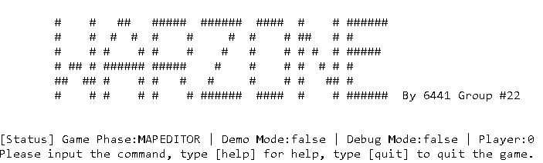

WARZONE is a console game.

Player can edit a map, add players, assign countries to different players, and issue orders for each player, after that game engine will run the reinforcement, issue order and execute orders in a loop until all the armies have been deployed to the countries.

There are 3 phases in the game:

* Map editor

Editing the continents, countries, and neighbors.

* Startup

Arrange the players and assign countries to players.

* Play

Reinforcement each player, issue the orders and execute the orders.

Design